**DAILY ONLINE ACTIVITIES SUMMARY**

|  |  |  |  |  |  |  |  |  |
| --- | --- | --- | --- | --- | --- | --- | --- | --- |
| **Date:** | **09/06/2020** | | | | | **Name:** | **Archana J C** | |
| **Sem & Sec** | **4th**  **‘A’** | | | | | **USN:** | **4AL18CS011** | |
| **Online Test Summary** | | | | | | | | |
| **Subject** | | **N/A** | | | | | | |
| **Max. Marks** | | **N/A** | | **Score** | | | **N/A** | |
| **Certification Course Summary** | | | | | | | | |
| **Course** | **Introduction to Digital Marketing** | | | | | | | |
| **Certificate Provider** | | | **Great learning academy** | | **Duration** | | | **2hours** |
| **Coding Challenges** | | | | | | | | |
| 1. **Write a C Program to rotate the matrix by K times.** | | | | | | | | |
| **Status: Completed** | | | | | | | | |
| **Uploaded the report in Github** | | | | | **Yes** | | | |
| **If yes Repository name** | | | | | **https://github.com/alvas-education-foundation/archana_j_c** | | | |
| **Uploaded the report in slack** | | | | | **Yes** | | | |

Online Test Details: (Attach the snapshot and briefly write the report for the same)

N/A

Certification Course Details: (Attach the snapshot and briefly write the report for the same)

#### COURSE NAME : Introduction to Digital Marketing

CERTIFICATION PROVIDERS : Great learning adademy

The course is about digital marketing which about 2 hours duration which includes Consumer Journey of Today, Explanation of New Medias, Understanding Brand Purpose, Introduction to Facebook Marketing, Purpose of using Facebook as Marketing Channel, Facebook Interface and Types of Audiences, Adset Set up guide, What is custom audience, Types of ads.

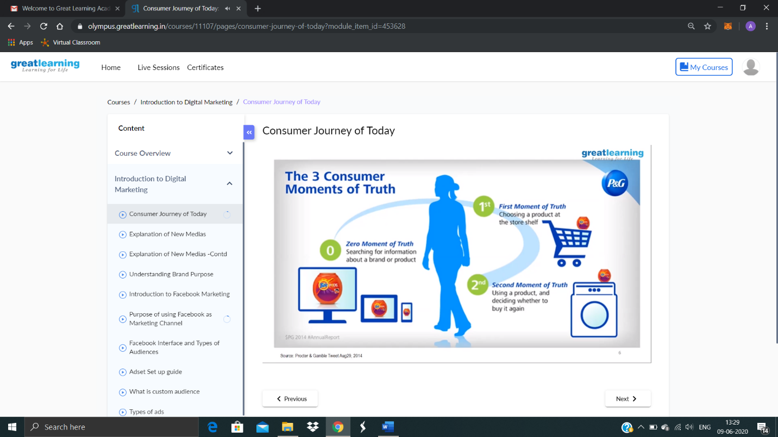

Coding Challenges Details: (Attach the snapshot and briefly write the report for the same)

Today I’m done with some c program. The solution are already uploaded in github repository.

Program1 : Write a C Program to rotate the matrix by K times.

